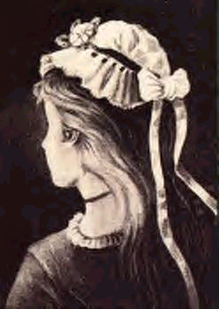
Old Woman...Or Young Girl?
hint: the old woman's nose is the young girl's nose and chin

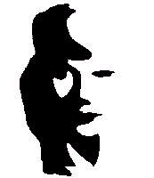
Man Playing Horn... Or Woman Silhouette?
(hint: woman’s right eye is the black speck in front of horn handle)

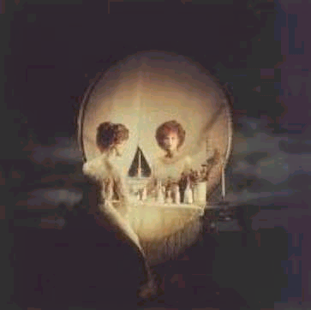

Woman In Vanity... Or Skull?
hint: move farther a bit from the screen and blink to see the skull or the woman (looking at the mirror)

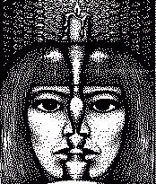
Two Faces... Or One?
(hint: two faces side profile…or one face front view)

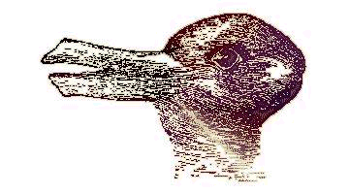
A Rabbit.... Or A Duck?
hint: the duck is looking left, the rabbit is looking right

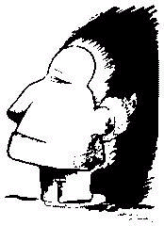
A Face Of A Native American... Or An Eskimo?

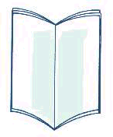
Is The Book Looking Towards You... Or Away From You?

